Report - Term Project

Luca Irimie

# UML Diagrams:

## Singleton for User Authentication:

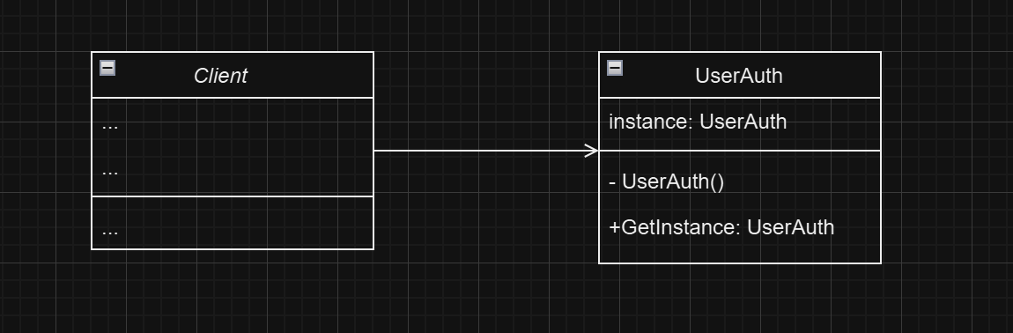

This Singleton pattern ensures that there exists only one session open at a time, making sure everything is secure for the user.

## Observer for Password Storage:

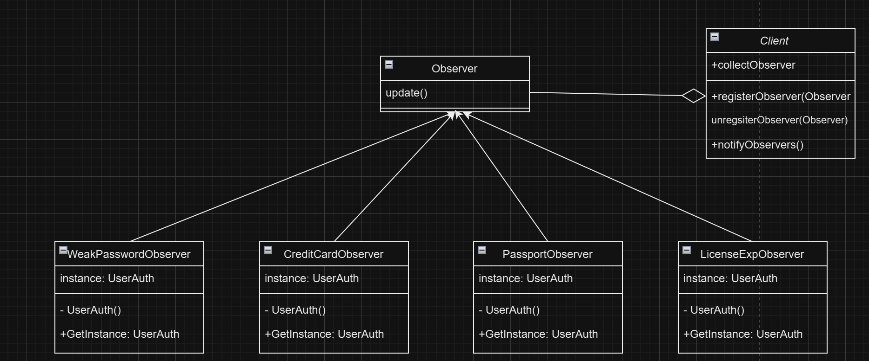

This pattern notifies the user when any of the following occur:

1. A password is too weak
2. A credit card has expired
3. A passport has expired
4. A license has expired

## Mediator for UI Elements:

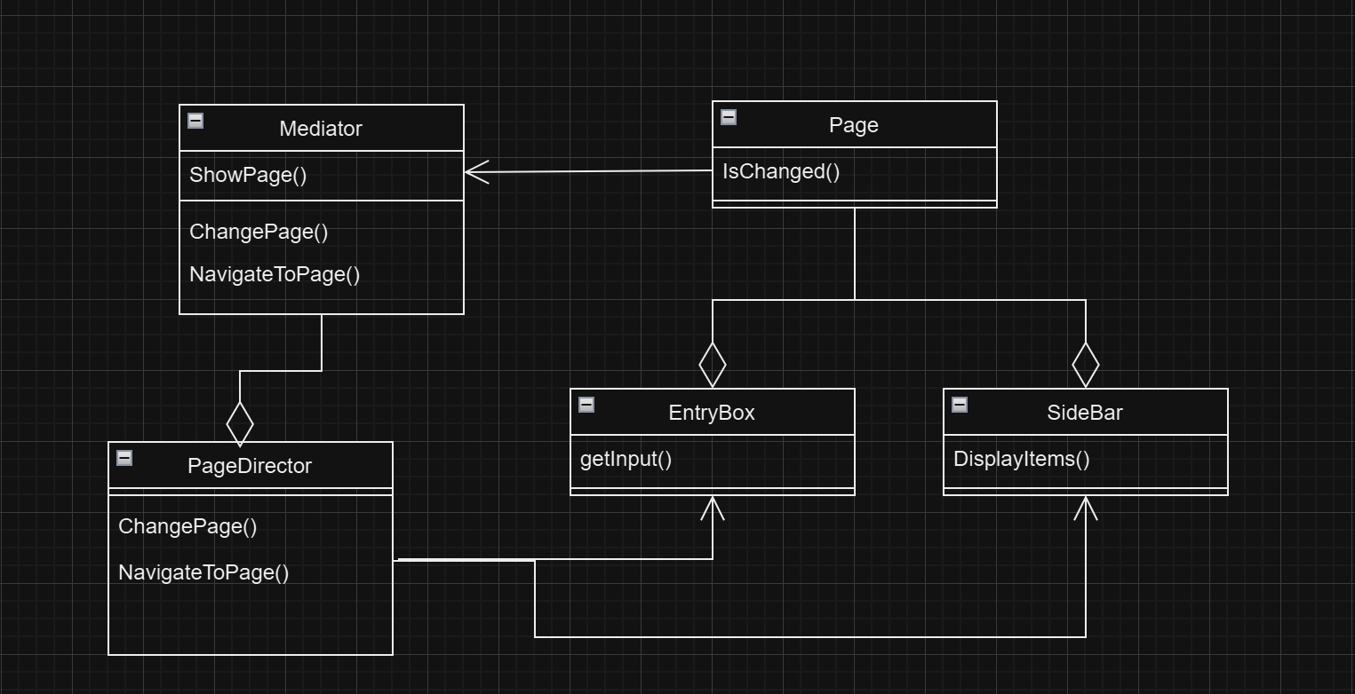

This Mediator Pattern keeps track of the various UI elements present in the application. The main elements are the Input boxes for the registration/login and the sidebar menu option. The Mediator class interfaces with the PageDirector class to concretely manage or “mediate” the two main UI elements.

## Builder pattern for Strong Password:

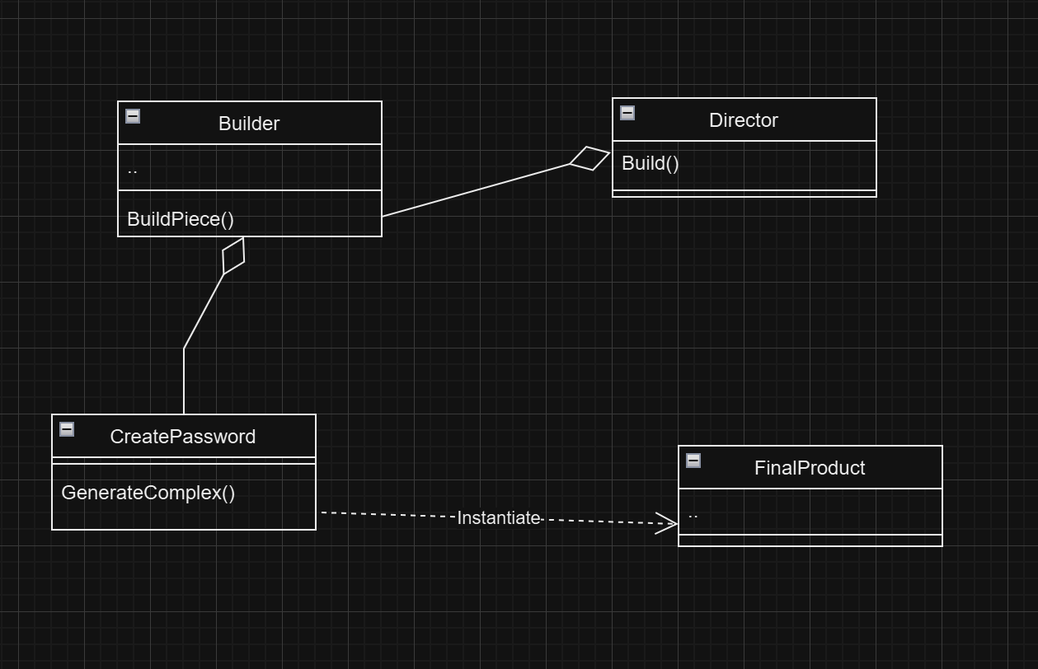

This pattern shows how to decouple the password generation process. The user directs a builder interface to create a complex password.

## Proxy Pattern:

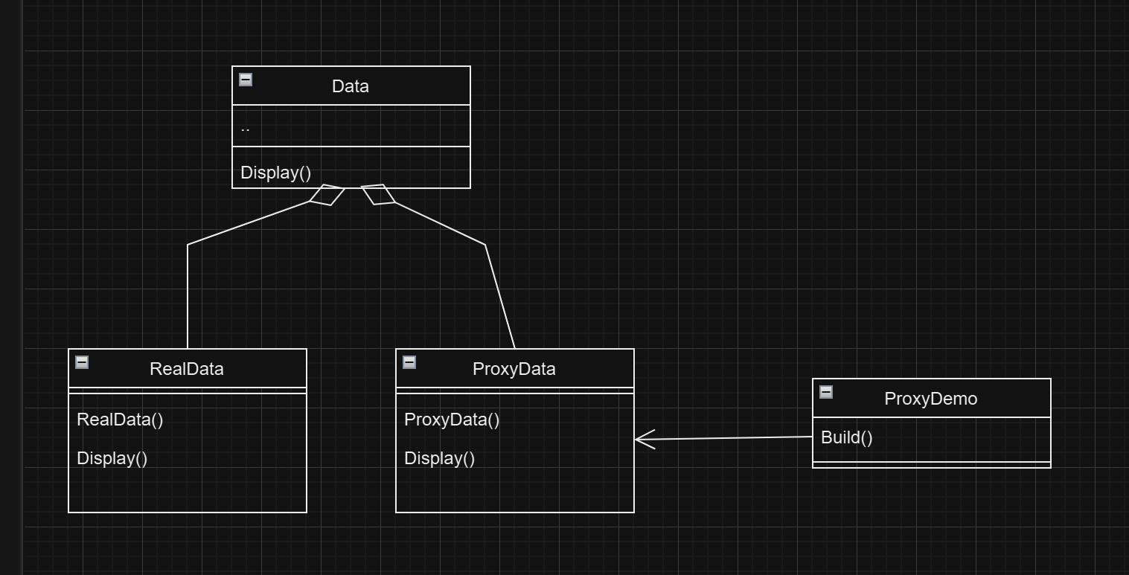

By masking the sensitive data, the user’s data can be safely encrypted.

## Chain of Responsibility Pattern:

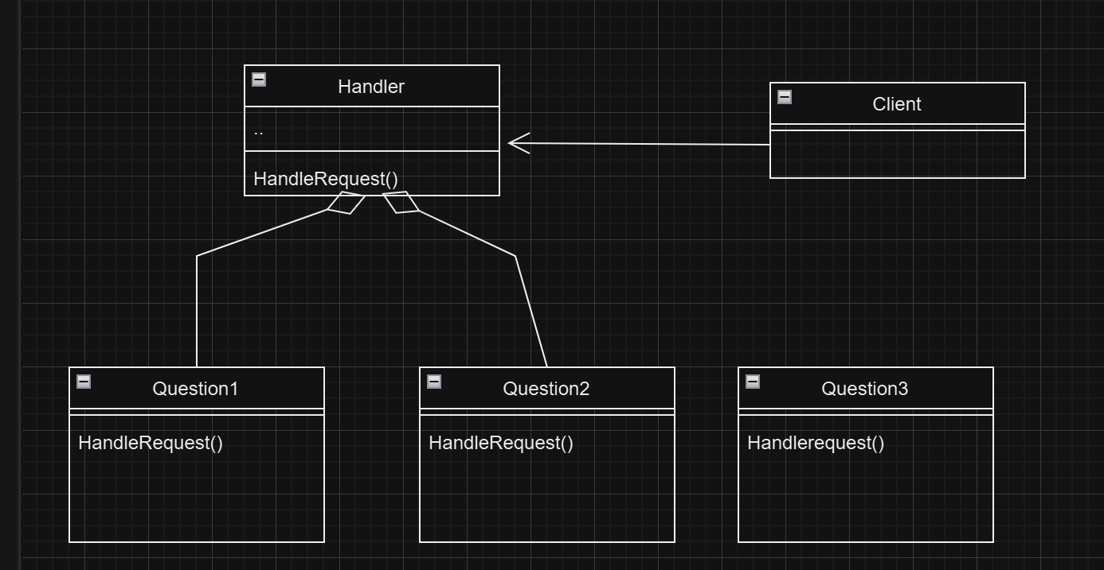

This diagram shows the chain of responsibility required for the program to keep track of the order of each security question.

# User Interface Screenshots:

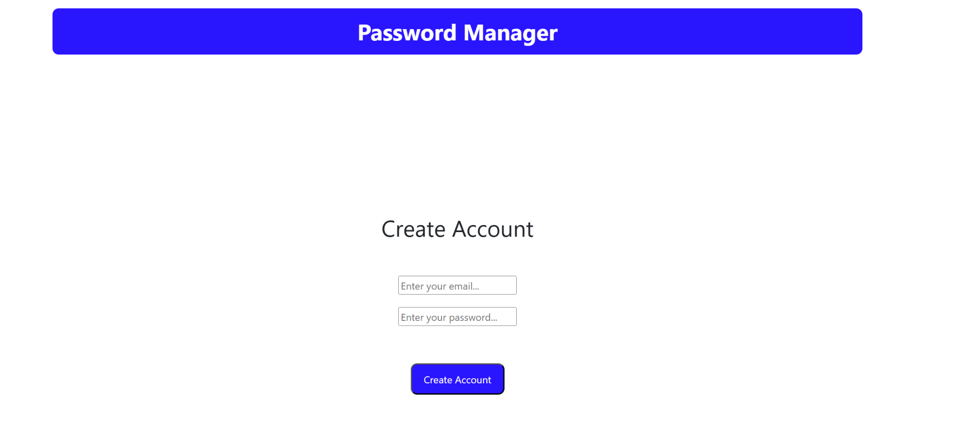

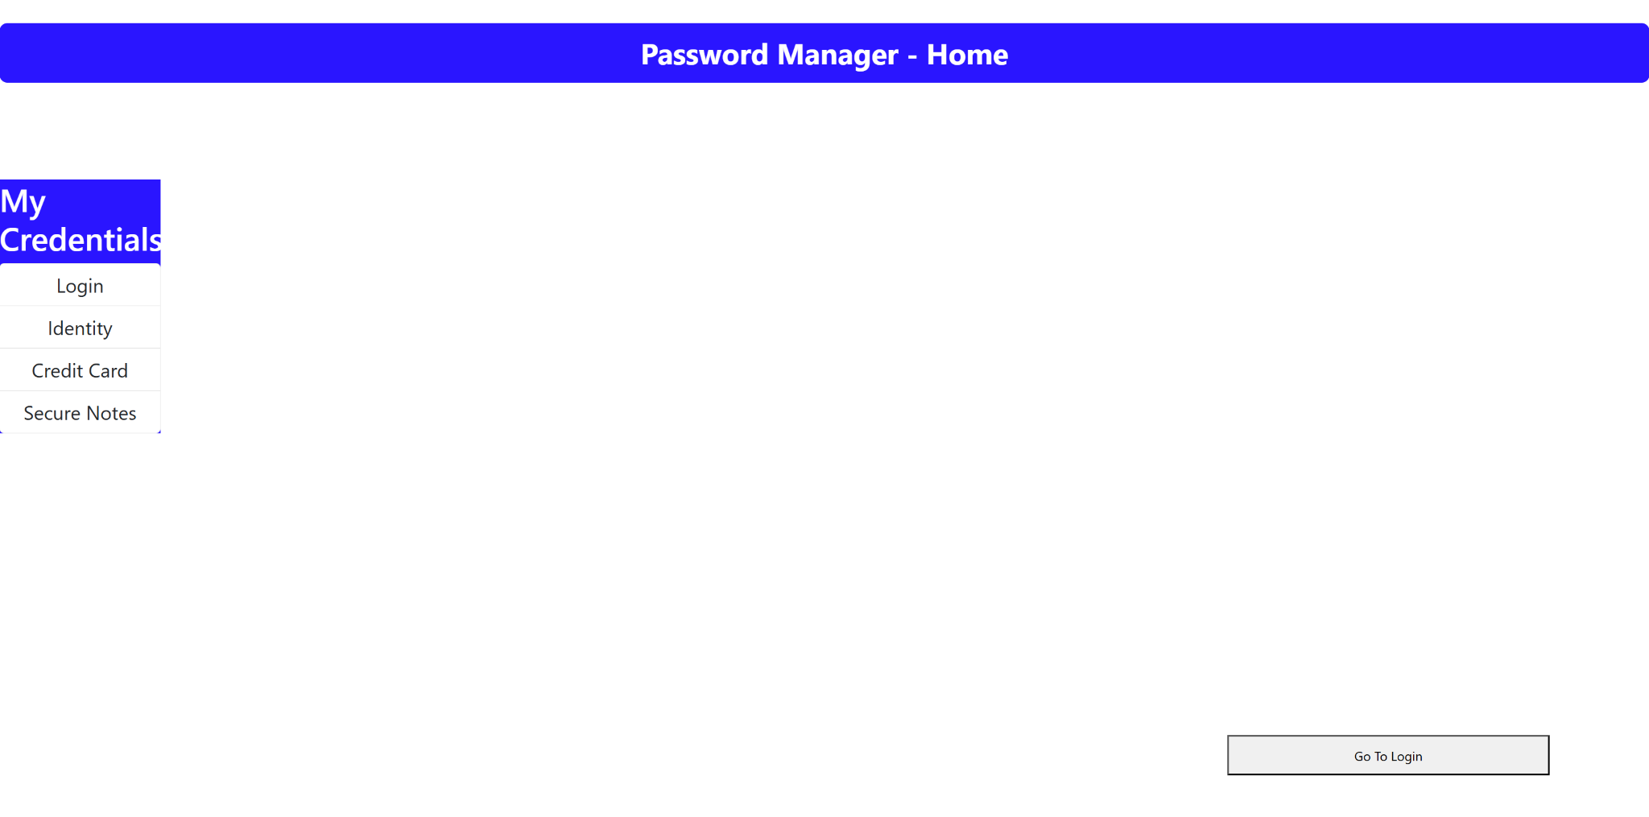

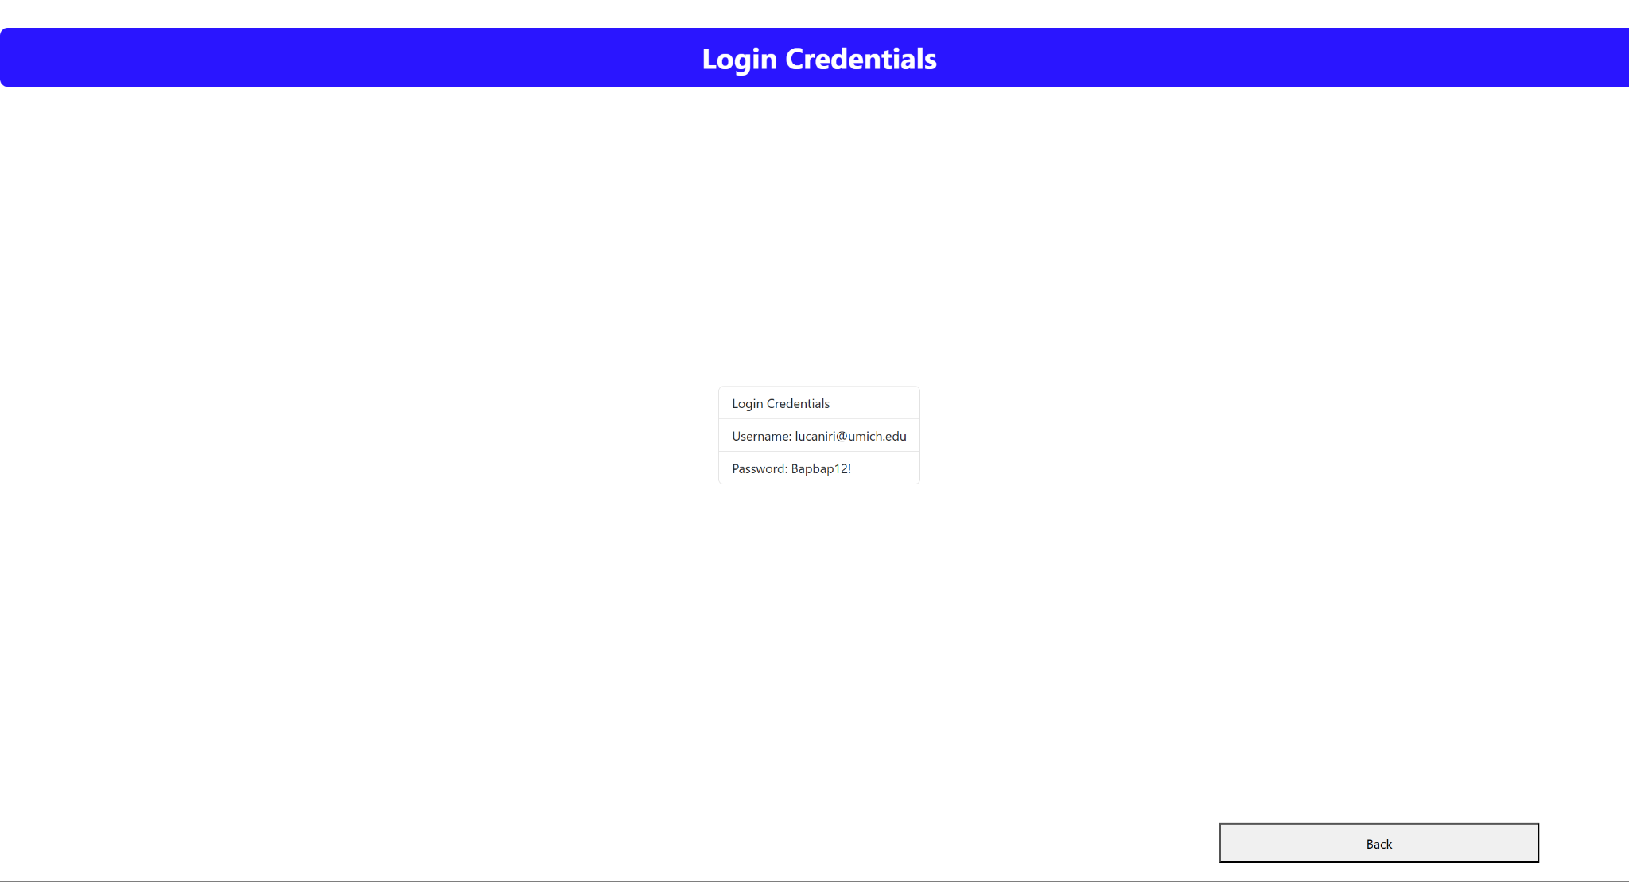

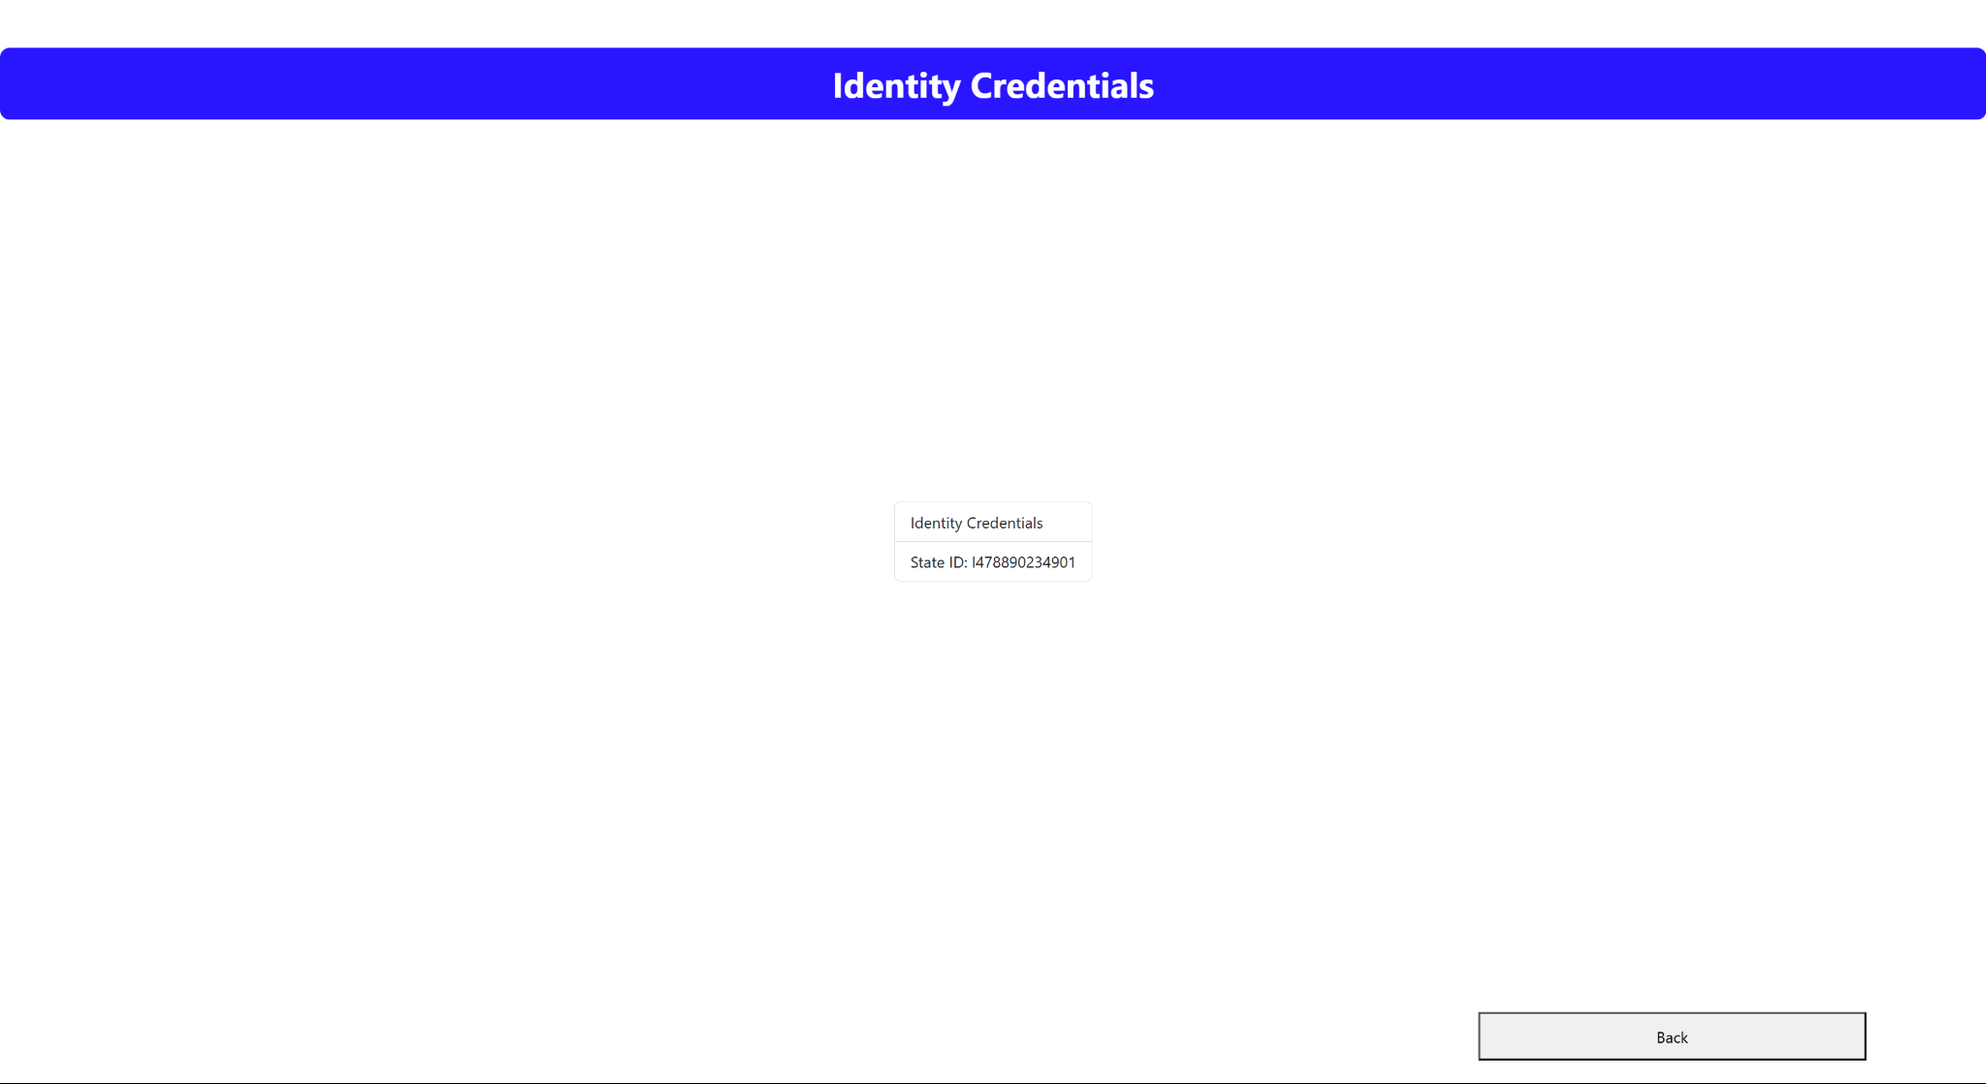

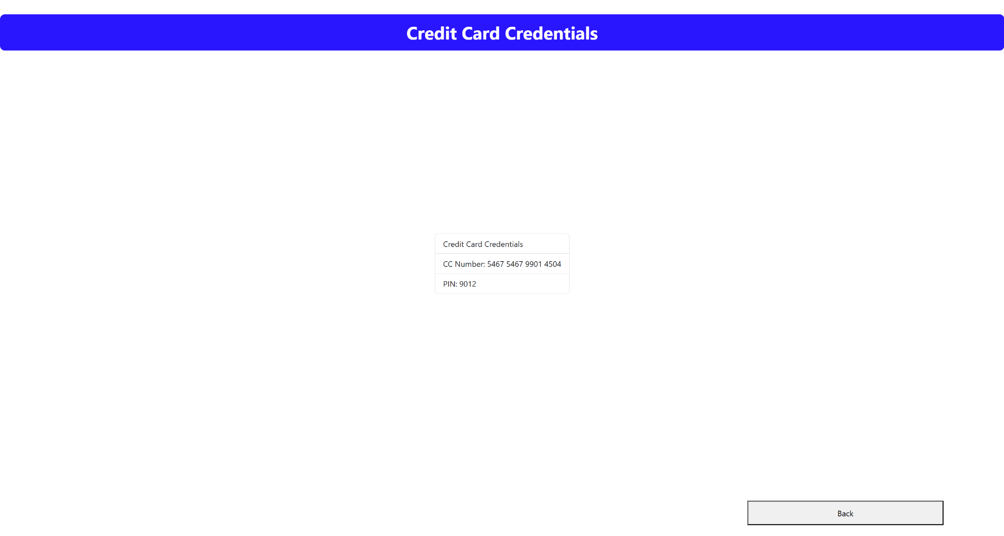

\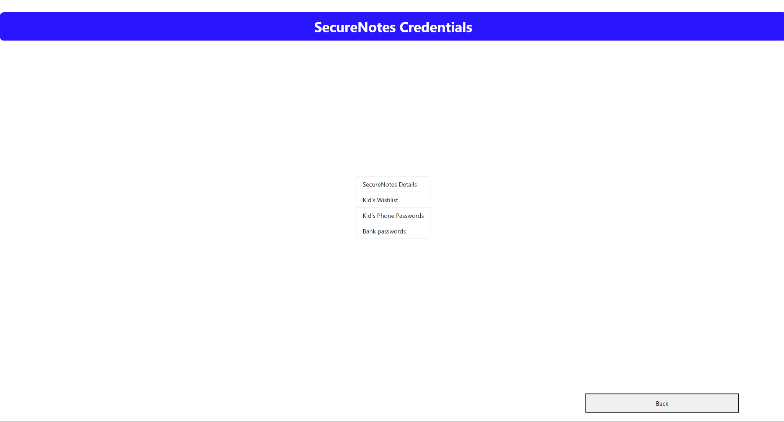

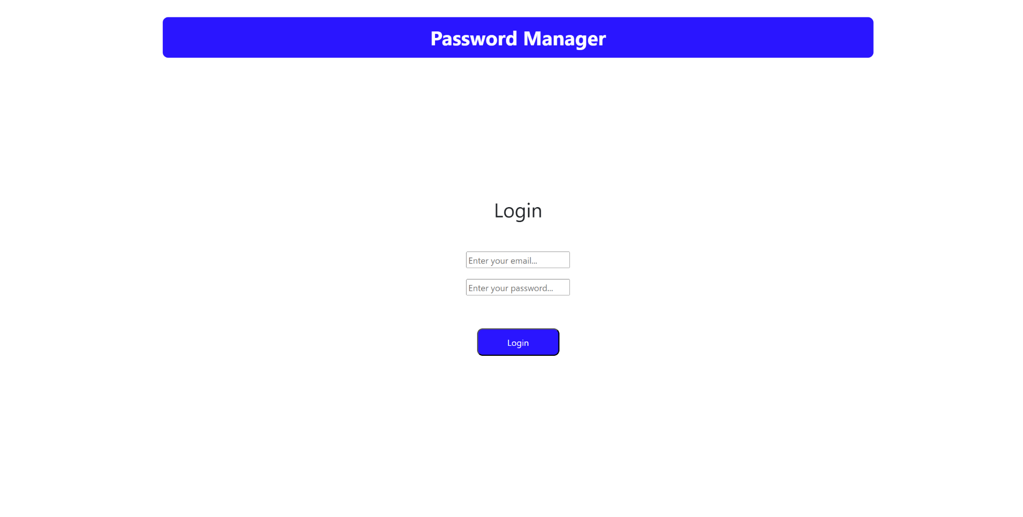

Overall description:

* Each screen has a back button that takes user back to the home page.
* If user wants to go back to login, the button on the home page takes them back.
* Users can view their credentials by choosing from the sidebar navigation menu.

# References

* <https://www.youtube.com/watch?v=SqcY0GlETPk&t=111s>
* <https://getbootstrap.com/docs/5.3/components/list-group/>
* <https://medium.com/@mechiranthan.y/a-step-by-step-guide-to-building-your-first-web-app-with-react-js-ad7bd6fe6e1b>